PHOTO BOOTH
This will be open and available starting at 7:00pm. Feel free to grab a prop and strike a pose (or a few poses!).
DESSERT TABLE
Snacks such as gelatin, fruit, and pastries are available. Cake, cake pops, and cupcakes are reserved for later.
REFRESHMENTS
Soft drinks, coffee, iced tea, and lemonade are available and free of charge. Alcohol is available until 11:15pm with Cash, Credit, and Debit payment options accepted.
DJ / MUSIC
Dancing is very highly encouraged. If you have a song you want to hear, please let DJ Will Lopez know.
……………………
FUN STUFF
ACROSS
8 - Something Ben is allergic to
9 - Type of stone in Cathy’s ring
11 - Name of our Honda Accord
13 - Type of metal in Ben’s ring
DOWN
1 - Type of unity ceremony performed
2 - Company where Ben & Cathy met
3 - Name of Cathy’s favorite band
4 - Main character in “Adventures of Tintin”
5 - Island that Ben lived on
6 - Name of our First Dance song
7 - One of Mikayla’s nicknames
10 - One of Leilani’s nicknames
12 - Months this wedding was planned in

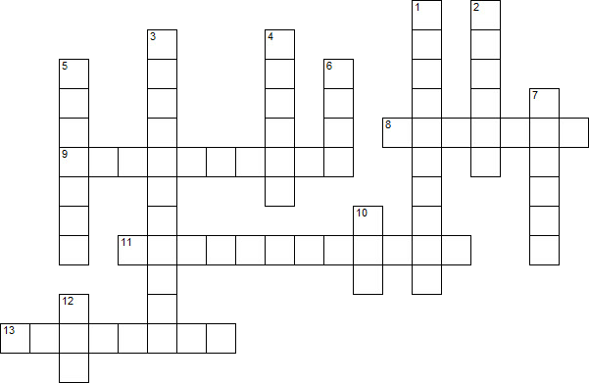
Ben
Cake
Cathy
Ceremony
Date
Decoration
Dress
Favors
Flowers
Guests
Invitation
Music
Party
Photos
Rings
Transport
Video
Wedding
w | e | d | d | i | n | g | e | k | a | c
n | r | c | h | r | c | e | n | a | n | t
o | i | v | e | r | y | r | s | t | r | m
i | n | v | i | t | a | t | i | o | n | u
t | g | t | r | d | s | s | p | h | s | s
a | s | a | a | e | e | s | o | c | r | i
r | p | t | u | s | n | o | c | e | o | c
o | e | g | s | a | s | t | w | e | v | a
c | c | e | r | e | m | o | n | y | a | t
e | r | t | n | n | l | h | a | e | f | h
d | i | i | p | f | r | p | t | r | b | y

